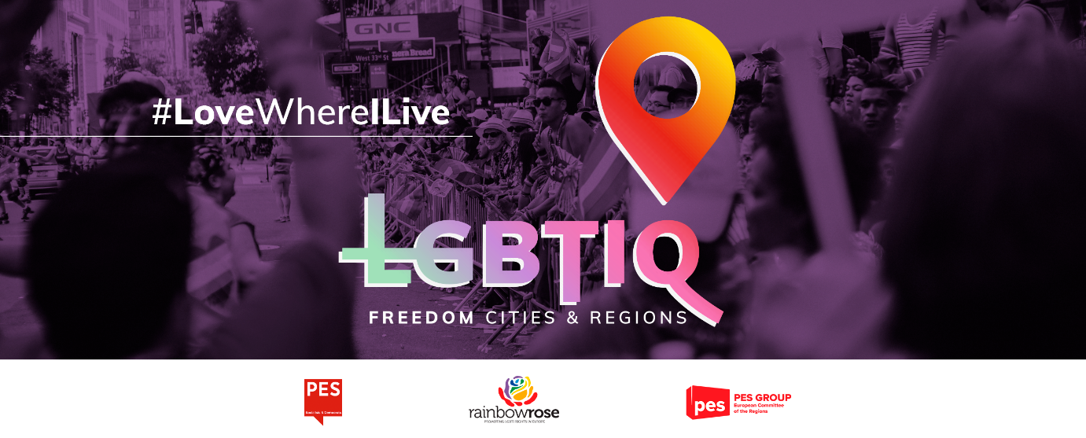

*The text of the sample resolution below can be adapted by interested municipalities, cities or regions to the specificities of their local or regional context.*

**Sample Municipal/City/Regional Council Resolution  
ON DECLARING ______________________ (name of the city/region) an LGBTIQ Freedom Zone**

The Municipal/Regional Council (delete as appropriate) of ______________________ (name of the city/region),

* having regard to the Charter of Fundamental Rights of the European Union,
* having regard to Article 2 of the Treaty on European Union (TEU),
* having regard to the European Convention on Human Rights and the related case-law of the European Court of Human Rights,
* having regard to the Universal Declaration of Human Rights,
* having regard to the resolution of the European Parliament on the declaration of the EU as an LGBTIQ Freedom Zone,
* having regard to the council resolution of the City of Lisbon on the declaration of the city as an LGBTIQ Freedom Zone,

1. whereas LGBTIQ rights are human rights and the right to equal treatment and non-discrimination is a fundamental right enshrined in the EU Treaties and in the Charter, and should be fully respected;
2. whereas since 2019, over 100 regions, counties and municipalities across Poland have adopted resolutions declaring themselves free from so-called LGBTI ideology or have adopted 'Regional Charters of Family Rights';
3. whereas in November 2020, the Hungarian town of Nagykáta adopted a resolution banning the 'dissemination and promotion of LGBTQ propaganda';
4. whereas these resolutions discriminate directly and indirectly against LGBTIQ people and have as direct consequence the increase in acts of violence, intolerance and hate speech directed against LGBTIQ persons or against persons who are considered to be LGBTIQ, according to a study conducted by the European Union Agency for Fundamental Rights in May 2020;
5. whereas the Commission has rejected applications for EU funding under its town twinning programme from Polish towns that had adopted LGBTI-free zones or family rights resolutions; whereas all EU funds managed under the Common Provisions Regulations 2021-2027 must respect the principle of non-discrimination and respect fundamental rights as set out in the Treaty, including on the basis of sexual orientation;
6. whereas while LGBTIQ persons in Poland and Hungary face systematic discrimination, this is also an issue across the EU, with little to no progress being made in alleviating the persistent discrimination, hate speech, hate crimes and harassment against LGBTIQ people; whereas LGBTIQ persons in every Member State still face a higher rate of discrimination in all areas of life, including at work and at school, and a high prevalence of physical, emotional and sexual attacks, both online and offline, which leads to a worrying suicide rate among young LGBTIQ people, and especially among young transgender people;
7. whereas combating inequality in the EU is a shared responsibility, requiring joint efforts and action at every level of government, and especially by local and regional authorities, which have a key role to play in this, being responsible for implementing three quarters of EU legislation and fostering equality and diversity;
8. whereas recognition, protection and advancement of the human rights of LGBTIQ people in Western Balkans is a crucial step in the EU accession process for the countries in the region, and considering that local LGBTI initiatives in fighting everyday discrimination and hate crime are key to raising awareness and fostering compliance;
9. whereas the Party of European Socialists Group in the European Committee of the Regions, together with the Renew Europe, European Alliance and the Greens, have called on the Committee to take a strong stance against breaches of LGBTIQ people's rights, such as the development of zones free from so-called LGBT ideology;

In view of the above, the Municipal/City/Regional Council (delete as appropriate) of ______________________ (name of the city/region) deliberates:

1. to declare ______________________ (name of the city/region) as an LGBTIQ Freedom Zone, following the European Parliament's declaration for the European Union of 11 March 2021, and commit to public policies promoting and protecting LGBTIQ rights on the one hand, and explicitly sanctioning structural discrimination mechanisms on the other;
2. to condemn the action of the Polish and Hungarian governments against LGBTIQ rights, in clear disregard of the Charter of Fundamental Rights of the European Union and the Universal Declaration of Human Rights, and every other form of discrimination against LGBTIQ persons;
3. to fly the Rainbow flag on the building of the ______________________ (municipality/city/region) during Pride Month.